RIGHT NOW TOMORROW
A letter

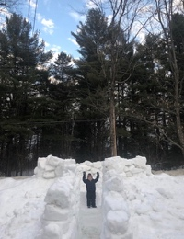

March 25, 2020

Dear friends and colleagues,
As things go, a few months might go by before we can really exchange any "normal" kind of news. Soooo, here I am, feeling the urge to share some thoughts with you just now. We are going through a planet-changing period . At this moment, there is 40 % of the earth’s population in confinement. This leads us to reinventing our lifestyles, modes of working and of being together. Being together while apart. And possibly questioning ever more so how to live together. This is the main issue of this century if not this millennium. In 2000, with PARACHUTE, we put out three journals on the Idea of Community starting with number 100. It then appeared to be THE question for the 2000s. It is more so today.

STONES
I often look at this image, a photograph by Wolfgang Laib. German by birth, he first trained as a doctor, and having travelled and lived in India since childhood, became an artist working on the most subtle issues. His work is about the simplest things and gestures: making, growing, form, change. Important change comes along in repetition. Philip Glass, Terry Riley and Steve Reich have composed music in this mode, music for a new world. Repetition is change, as it proceeds as an ongoing investigation and focuses on difference. Paul Auster in his book The Music of Chance describes the building of a stone wall over many pages: it is at the core of the book. Chance and change often work together. This moment is a chance for change. Confinement is a gift in the sense that it gives time to think about change. Hence, we can raise our arms and open our minds, to celebrate this unique moment, just as this child who salutes us at the beginning of this letter.

LIFE IN THE WOODS ?
In his book Walden, Henry David Thoreau describes how he lived in isolation in a cabin he built on Walden Pond almost two centuries ago. Many people are reading Walden now as it talks about changing one’s lifestyle and building a relationship with nature, plants, animals, one’s own human nature and its connection to the living world in proximity. A major part of the book is on Economy. More than about living in a cabin in the woods, in my mind it has to do with negotiating a different (less ideological more pragmatist) relationship to the environment, to planet Earth.
I fell upon Walden by chance about a year ago and have been gravitating around these ideas through many other books ever since, Donna Haraway, Bruno Latour, Isabelle Stengers, Kenneth White, and to this particular constellation I should add Catherine Malabou as her last book deals with mutations, including those coming out of AI, deemed to gain in importance in the aftermath of the current crisis, or Achille Mbembe who questions contemporary geo-political dynamics, touching upon geo-poetics. Remember Wittgenstein’s phrase: “ethics and aesthetics are one”? This is what Thoreau is about. Conversations with artists enabled me to discover their strong fascination with Walden. All of this research, or should I consider it an investigation or a passion even…, is leading to an exhibition/event. More to be done around life on earth and how to deal with it at this point.

TREES
In the beginning of the year, I sent you all a greeting card with an image of trees. Along with it, I quoted the poet Anna Akhmatova who experienced great pain: “Everything lights up between the trees”. Another project I am working on is finding a house in the country with a lot of trees around it. I am especially thinking about the tall white pines in the village I grew up in, Rawdon. They link the earth to the cosmos in this small village. I have an urge to live with them and for them to accompany me in my everyday life. This house will be a refuge, but not in the sense of providing isolation or distancing for oneself. On the contrary, I feel my sense of connectivity will become greater than ever. I see it as a live laboratory. A place to experiment, differently, and where WORKS can happen everyday, that is We Others and Myself Researching Knowledge Systems, a concise definition of my working methods. As the world goes, being TOGETHER APART seems to be the way to go, and the way to be. This includes plants and animals as well. And this gesture will reflect my contribution to a green planet.
MOVING
I started working on a book during the month I spent in 2018 on Fogo Island, benefitting from a studio with a view on the ocean. The idea spurred about a few months before when Dora Garcia asked me to write about exile for one of her projects. The book project immediately appeared to me as I realized I had probably much to say about Moving, Living, and Change. The book is comprised of five chapters:
- The first stemming from my great-grandfather immigrating from Sorel, Quebec, to New England in the context of the industrial revolution and the French-Canadian diaspora. My grandfather was born there and as an adult played the violin all his life. Moving around incessantly for his work, the violin became his companion and gave his life more meaning.
- The second revolves around my father’s life as an opera singer in New York at the beginning of the XXth C, when New-York’s population was made up by 75% immigrants. The impact of this pre-globalization phenomenon urged him to leave behind a successful career and, as he had some training early on as an architect, came back to his home country to develop a garden city (a cité champêtre as he called it, akin to the garden cities of which he had experienced the oncoming in America). This he did in Rawdon, the context in which I was born.
- The third has to do with the XXIst C and the ten years or so I spent in Europe as globalization was hitting hard. I had already reoriented PARACHUTE and the FIND (international new dance festival in Montreal), two organizations I had been president-director of for a long time, in view of the challenges ahead of us. The decade was the chance to think out and produce several innovative projects in order to address the new millennium: amongst them HF/RG at the Jeu de Paume, Mutations for Paris Photo, Nomadic Geographies for the Beaux-Arts, The Yvonne Rainer Project in several institutions in London and Paris, PER/FORM How to do things with[out] words in Madrid. And also, the two years I spent in London working for the new Tate Modern as it was aiming to emblematize the museum of the XXIst C, then for the Luma Foundation which also had in mind to build a museum for times to come.
- The fourth has to do with the year I then spent in Toronto, a city which has become a world laboratory with 53% immigrant population form over 200 countries, changing in a few decades form a very homogeneous milieu to an extraordinarily heterogeneous one. My job there was to build the foundations for a XXIst C museum within this specific context.
- The fifth and last, revolves around an exile that belongs to all of us, that of death. Raymond Gervais, my life companion, died in 2018 following a few months of unannounced illness. Fernand Dumont, the father of sociology in Quebec, concluded that his life course had been an emigration through culture. Likewise for Raymond. His lifework as an artist deals with many issues I have brought up here: living surrounded by others, chosen figures in history, artist colleagues, technologies of communication, natural phenomenon such as wind, tornadoes, together with tropes of repetition, whiteness, as background and light. The blank page. And sound with or without sound. Race, pain, handicaps are all subjects he dealt with from time to time. But also death. Death as an opening, not a closure. And something should be said someday about the immense impression of empathy that emanates from his works. We need empathy !
The book is called EXIL[E] and is subtitled Aesthetics and Migrations. How movement, distancing, even isolation or death meet change, and nourish the course of aesthetics. And how one interacts with the other. A trope that is being shared by many of us, more and more.
And another view of how art works and the effect migration has on political life and culture.

SPHERE(S)
SPHERE(S) is a new model for an international contemporary art event I have been developing in Montreal recently. SPHERE(S) will be coming... later when things calm down. We will need it ! For the moment, there is an eclipse happening. It is a time for observation and refocusing, as destabilizing as it may seem. Very grateful to all those involved and supporting the project so far.
WHAT IS TO BE DONE
I leave you with this image from Yvonne Rainer’s film Hand. As she was confined in a hospital as a young woman and unable to dance as she would in her everyday life, a friend came by to see her and brought along a camera. He filmed her making a chorography with the fingers of her right hand she had presented to the camera. This simple film is a favorite of mind, as it provides constant guiding in my life dealing with change and beauty, especially in times of difficulty.
We need two things I feel, at this moment, trees and courage. Both to reinvent the world we live in, and possibly reinvent ourselves. In 2010, I was asked to curate a symposium in Athens for the annual IKT curators' congress. It was in the midst of the economic world crisis that had just struck the world. Athens was one of the first places hit. I felt it necessary to address the concept of Courage. It seemed important to put courage forward in a time when emphasis was being put mainly on economic damages. I still believe that today.
Courage everybody, take care, of yourself, and of others,
Chantal Pontbriand
e-mail : chantal.pontbriand@gmail.com
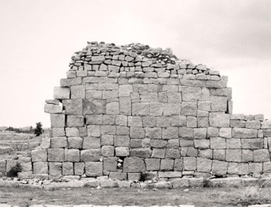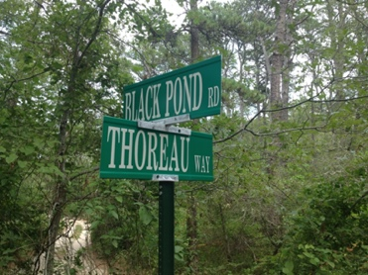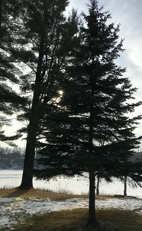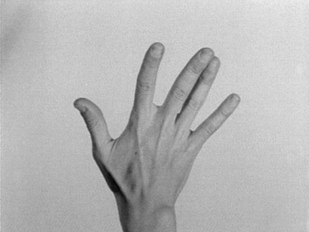
Thank you little Arthur and papa Antoine, Wolfgang Laib, Vincent Meessen, the sun, and Yvonne Rainer for these images.

Links:
PARACHUTE 100-103 THE IDEA OF COMMUNITY_L’IDÉE DE COMMUNAUTÉ:
Nº 100 Jan 2000
http://numerique.banq.qc.ca/patrimoine/details/52327/3645332?docsearchtext=Parachute%20octobre%202000
Nº March 2000
http://numerique.banq.qc.ca/patrimoine/details/52327/3645334?docsearchtext=Parachute%20janvier%202000
Nº 102 June 2000
http://numerique.banq.qc.ca/patrimoine/details/52327/3645336?docsearchtext=Parachute%20avril%202001
SPHERE(S)
http://m.ledevoir.com/article-508478
http://m.ledevoir.com/article-508500
In English https://www.dropbox.com/s/syfxqmlpcfve8eu/SPHERE%20%28S%29%2C%20short%20version%2C%20ENG.pdf?dl=0
COURAGE !!! : Keynote lecture
https://www.youtube.com/watch?v=ohsvY836320
https://www.youtube.com/watch?v=lxuGDL_8AYY
Text here:
https://www.dropbox.com/s/0xlsjg9y38dveww/COURAGE %21%21%21 %28Athens,2010%29.doc?dl=0

